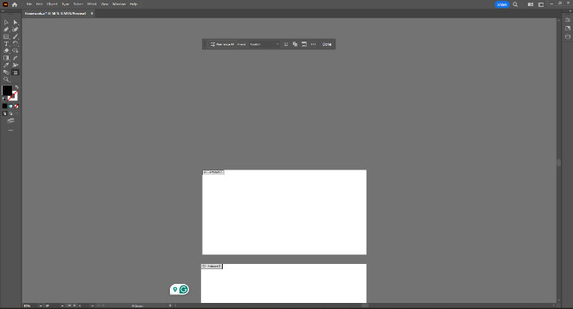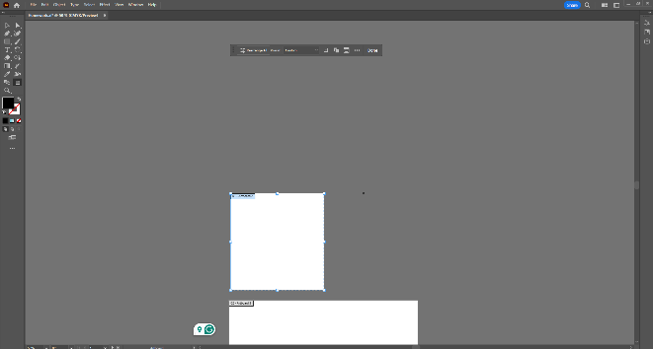

The artboard tool can be used to scale and create the artboard to scale with what project your working on.

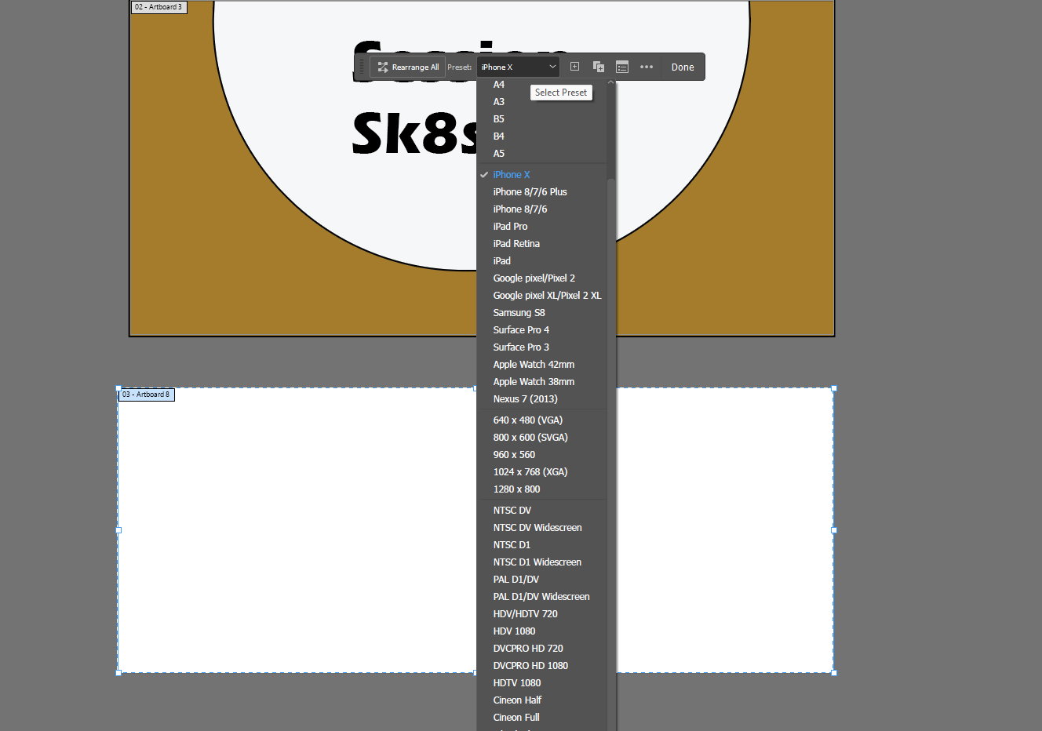

Additionally you can use the artboard to make a preset depending on the current project your working on currently

**Use the Shape Builder tool.**

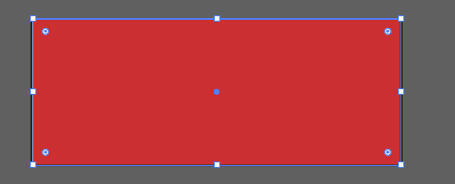

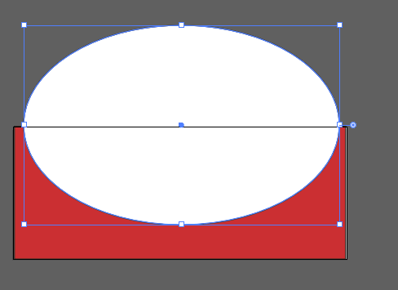

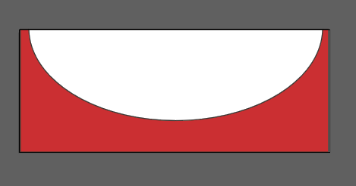

**Add and format text.**

**Create and modify swatches.**

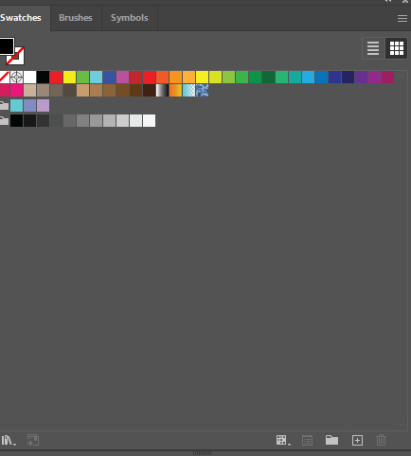

Go to color swatches menu and click the + symbol below.

If you wish to modify it go to your swatches click on one of the available swatches and click on the newly created switches and edit it to your wishes

Selecting the text tool and add it to the road lines and type out your text

**Convert text to outlines.**



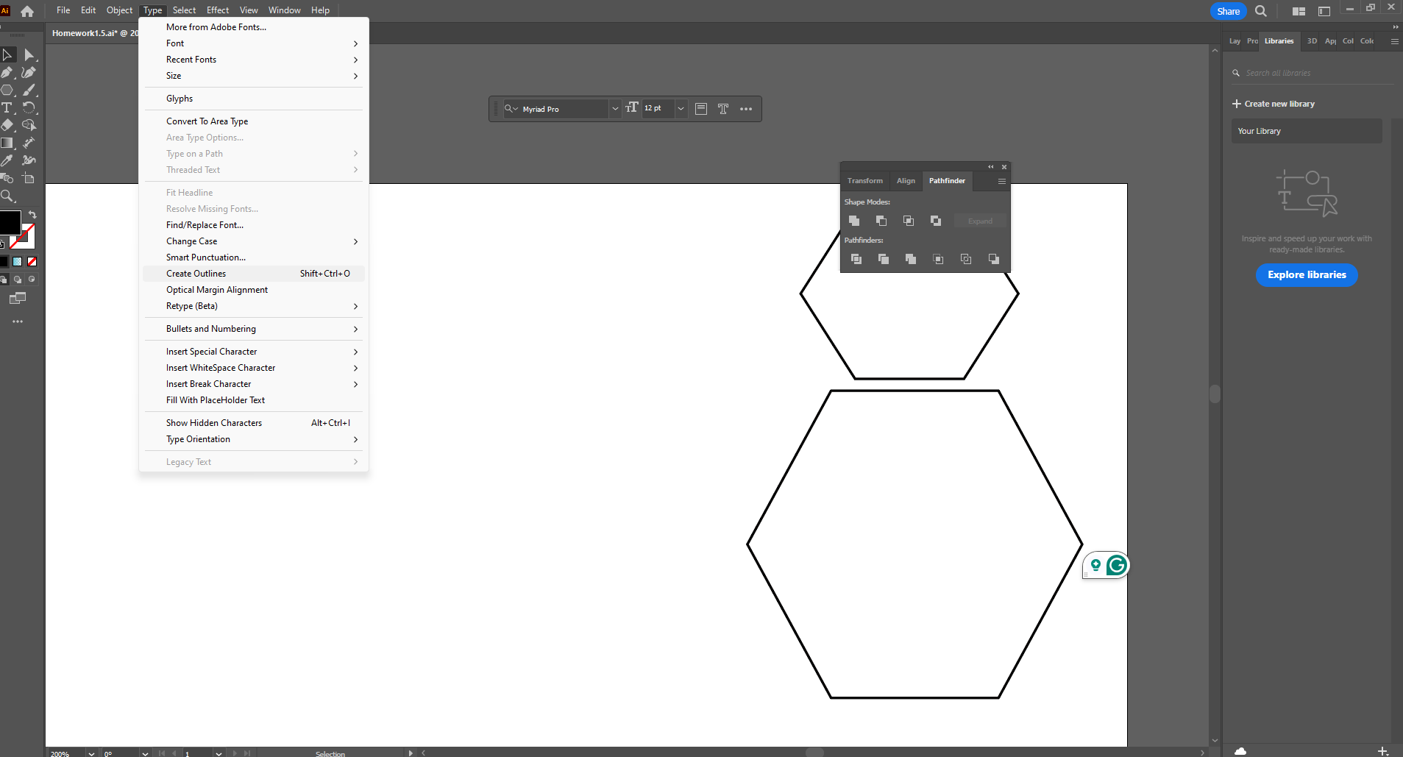



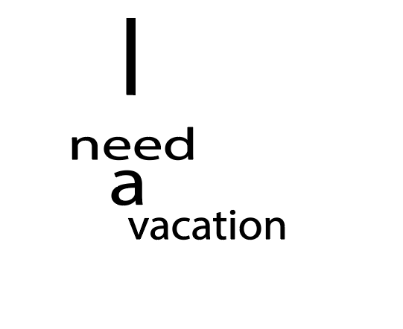

Use the **Selection Tool** (V) to click on the text that you want to convert to outlines.

If your text contains multiple characters, Illustrator will group them after conversion.

Now that your text is converted to outlines, it is no longer editable as text. However, you can manipulate it as vector shapes.

Use the **Direct Selection Tool** (A) to move anchor points, change the shape of individual characters, or apply other modifications.

**Use the Color Guide panel to create swatches.**



Go to color swatches menu and click the + symbol below.

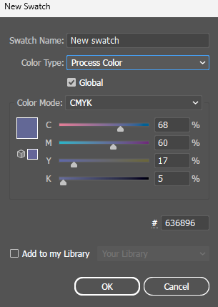

Adjust the color to your desire

**Use the Pathfinder panel to modify objects.**

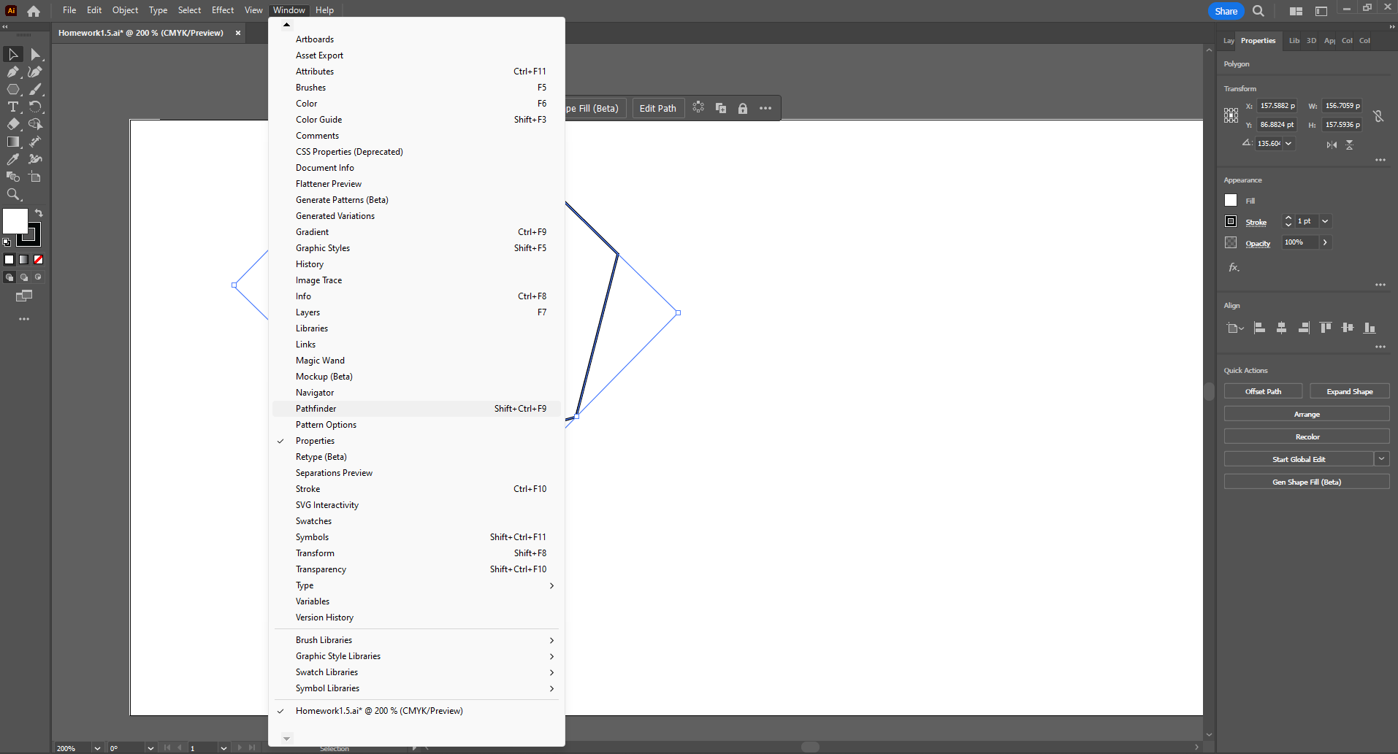

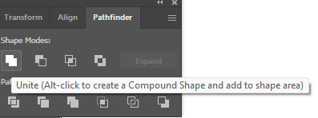

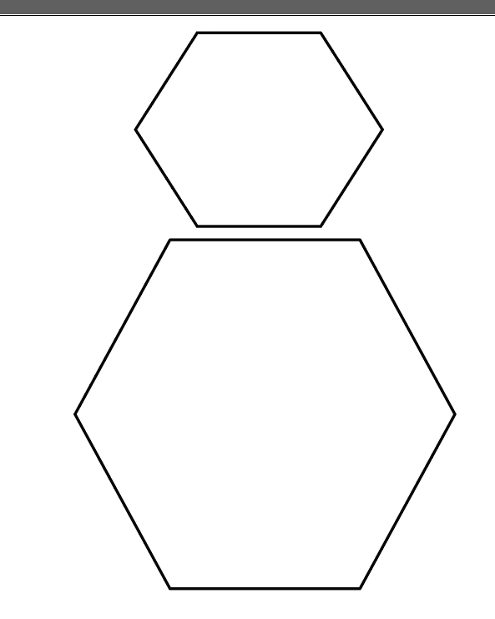

Make two shapes and go to window and select the pathfinder tool and select to join two shapes together

# Learning Units 3







* Create a circle and rectangle shapes like displayed above.
* Go to the custom shape tool